**Recommendation Engine Tuning - Entertainment Sector**

Pooja Joshi & E.Code [E25007]

# Overview :

# The report details the process and progress made in developing a recommendation engine for the entertainment sector. It covers the objectives, tasks performed, challenges faced, and next steps to enhance the recommendation engine's performance.

# Objective:

To tune a recommendation engine for the entertainment sector by incorporating item features and expanding the dataset for improved recommendations.

# Assigned Task(s) :

· Expand the dataset with additional items.

· Incorporate more item-specific features like genre and popularity.

· Visualize recommendations based on user input.

# Task Details :

· **Task 1: Expand Dataset and Incorporate Features**

* **Status:** In Progress
* **Details:** Added more movies to the dataset and included relevant features such as genre, popularity, and average ratings. Implemented normalization techniques for numerical features.

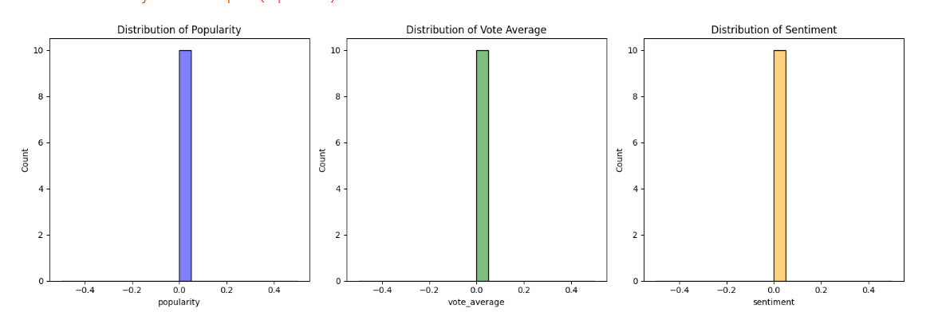

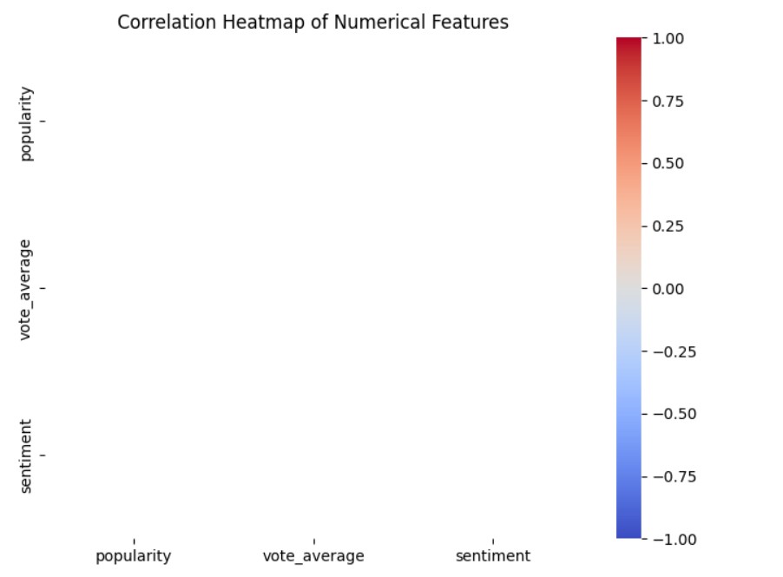

· **Task 2: Recommendation Engine Development**

* **Status:** In Progress
* **Details:** Developed a content-based recommendation engine utilizing user-item interactions and similarity measures. Addressed the challenge of having insufficient data for matrix factorization.

# 

# 

**Progress :**

· **Accomplishments:**

* Successfully expanded the dataset and added new features, allowing for better recommendations.
* Created a preliminary recommendation system that utilizes similarity measures.

· **Metrics:**

* Unique users in the dataset: 7
* Unique items in the dataset: 1 (highlighting the need for dataset expansion)

# Challenges and Solutions :

· **Challenges Faced:**

* Encountered issues with insufficient data, leading to errors in matrix factorization.
* No recommendations were displayed due to the lack of valid movie titles in the dataset.

· **Solutions Implemented:**

* Suggested and implemented the expansion of the dataset by incorporating more movies and features.
* Improved the recommendation function to handle cases where no matching titles are found, providing user feedback.

# Next Steps :

· **Upcoming Tasks:**

* Continue expanding the dataset by adding more movies and their corresponding features.
* Enhance the recommendation algorithm to include collaborative filtering methods for improved accuracy.

· **Goals:**

* Aim to have at least 50 unique items in the dataset by the next session.
* Implement a more robust recommendation system that can handle a wider range of user inputs.

# Conclusion :

# Summary: This report outlines the application of the ARIMA model to forecast movie popularity, providing valuable insights into potential future content demand. The next steps will focus on refining the model and validating its accuracy against real-world factors.

# **Acknowledgments**: Thank the audience for their time and attention.